**Insert School Logo**

**Semester Two Examination 2019**

**Question/Answer Booklet**

**MATHEMATICS**

**METHODS UNITS 3 & 4**

**Section One:**

**Calculator–free**

|  |
| --- |
| Student Name: _____________________________________ |
| Teacher‘s Name: _____________________________________ |
|  |

**Time allowed for this section**

Reading time before commencing work: five minutes

Working time for paper: fifty minutes

**Material required/recommended for this section**

**To be provided by the supervisor**

This Question/Answer booklet

Formula Sheet

**To be provided by the candidate**

Standard items: pens(blue/black preferred), pencils(including coloured), sharpener, correction tape/fluid, erasers, ruler, highlighters

Special Items: nil

**Important note to candidates**

No other items may be taken into the examination room. It is **your** responsibility to ensure that you do not have any unauthorised notes or other items of a non–personal nature in the examination room. If you have any unauthorised material with you, hand it to the supervisor **before** reading any further.

**Structure of this paper**

|  |  |  |  |  |  |
| --- | --- | --- | --- | --- | --- |
|  | Number of questions available | Number of questions to be attempted | Working time (minutes) | Marks available | Percentage of exam |
| **Section One**  **Calculator—free** | **9** | **9** | **50** | **52** | **35** |
| Section Two  Calculator—assumed | 15 | 15 | 100 | 98 | 65 |
|  | | | |  | 100 |

**Instructions to candidates**

1. The rules for the conduct of Western Australian external examinations are detailed in the *Year 12 Information Handbook 2019.* Sitting this examination implies that you agree to abide by these rules.
2. Answer the questions according to the following instructions.

Section One: Write answers in this Question/Answer Booklet. Answer **all** questions.

**Show all your working clearly.** Your working should be in sufficient detail to allow your

answers to be checked readily and for marks to be awarded for reasoning. Incorrect

answers given without supporting reasoning cannot be allocated any marks. For any

question or part question worth more than two marks, valid working or justification is

required to receive full marks. If you repeat an answer to any question, ensure that you

cancel the answer you do not wish to have marked.

It is recommended that you **do not use pencil**, except in diagrams.

1. You must be careful to confine your responses to the specific questions asked and to follow any instructions that are specific to a particular question.
2. Spare pages are included at the end of this booklet. They can be used for planning your responses and/or as additional space if required to continue an answer.

* Planning: If you use the spare pages for planning, indicate this clearly at the top of the

page.

* Continuing an answer: If you need to use the space to continue an answer, indicate in the original answer space where the answer is continued, i.e. give the page number. Fill in the number of the question that you are continuing to answer at the top of the page.

1. The Formula Sheet is **not** handed in with your Question/Answer Booklet.

# Section One: Calculator–free 52 marks

This section has **nine (9)** questions. Attempt **all** questions. Write your answers in the spaces provided.

Spare pages are included at the end of this booklet. They can be used for planning your responses and/or as additional space if required to continue an answer.

* Planning: If you use the spare pages for planning, indicate this clearly at the top of the page.
* Continuing an answer: If you need to use the space to continue an answer, indicate in the original answer space where the answer is continued, i.e. give the page number. Fill in the number of the question(s) that you are continuing to answer at the top of the page.

Working time: 50 minutes

**Question 1 (4 marks)**

Given the following: 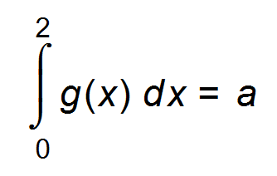

(a) Determine 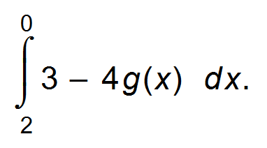 (2 marks)

(b) Evaluate *a* if 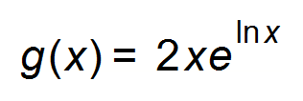. (2 marks)

**Question 2 (6 marks)**

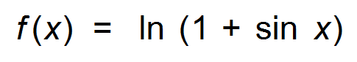where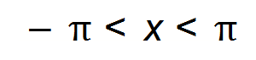

1. Determine the coordinates of the stationary point(s) of the graph of the function. (3 marks)

(b) Evaluate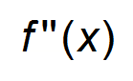and hence state the nature of the stationary point(s) found in (a). (3 marks)

**Question 3 (3 marks)**

The cubic function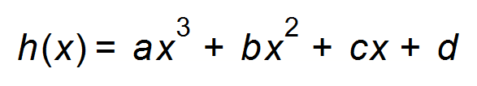has a point of inflection at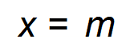.

Show that 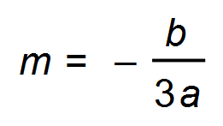. (3 marks)

**Question 4 (8 marks)**

(a) Solve the following for *x*

(i) 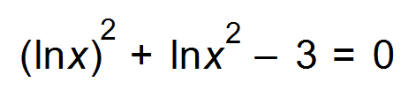 (3 marks)

(ii) 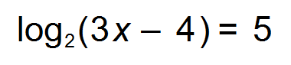  (2 marks)

(b) Find the equation of the tangent to the curve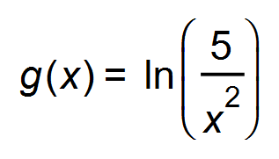at the point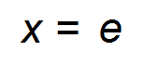. (3 marks)

**Question 5 (8 marks)**

(a) If Y is a random variable such that Pr (Y > 7) = *a* and Pr (Y > 10) = *b*, then determine

Pr (X < 7| X < 10) in terms of *a* and *b*. (2 marks)

(b) A 95% confidence interval for the population proportion, *p*, for the number of televisions per Australian household is (1.15, 4.20).

For each of the following statements about this confidence interval, choose True or False.

For the statements that are False, explain why they are False. (6 marks)

(i) The probability that *p* is between 1.15 and 4.20 is 0.95.

(ii) 95% of all Australian households have between 1.15 and 4.20 televisions.

(iii) If 100 intervals were calculated in the same way, we expect 95 of them to contain the population proportion.

(iv) If 100 intervals were calculated in the same way, we expect 100 of them to capture the sample proportion.

**Question 6 (9 marks)**

The velocity of a particle is given by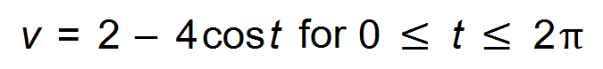where *v* is measured in metres per second and *t* is measured in seconds.

(a) At what times during this period is the particle at rest? (2 marks)

(b) Determine the maximum velocity of the particle during this period. (3 marks)

(c) Calculate the total distance travelled by the particle between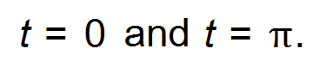

(4 marks)

**Question 7 (6 marks)**

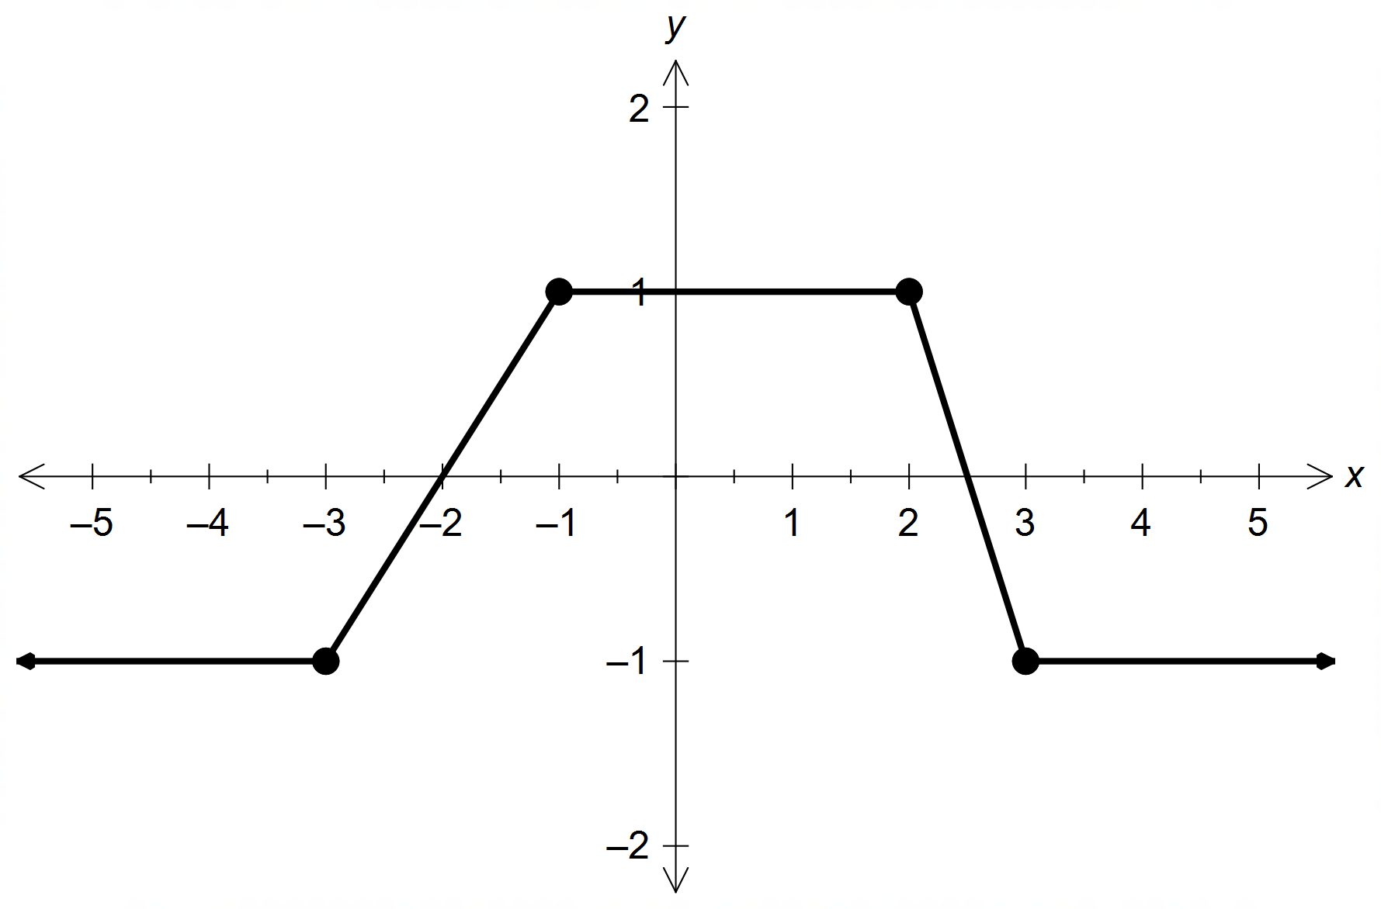(a) The diagram shows the graph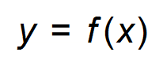.

Determine the value of *p*, where *p* > 0, so that 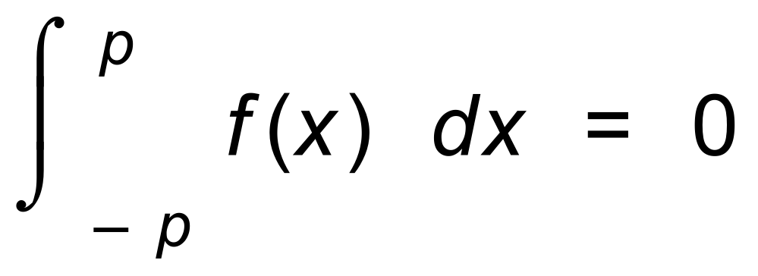.

Show your reasoning. (3 marks)

(b) Determine 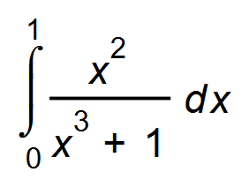 (3 marks)

**Question 8 (4 marks)**

(a) Find b in terms of a for the following: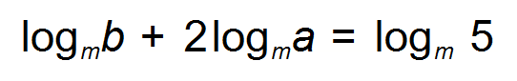 (2 marks)

(b) Simplify the following. (2 marks)

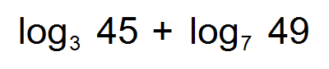

**Question 9 (4 marks)**

The graphs of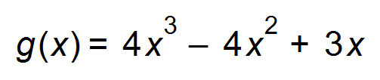and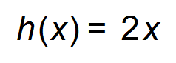meet at *O* and at *W.*

Find the area of the shaded region. (4 marks)

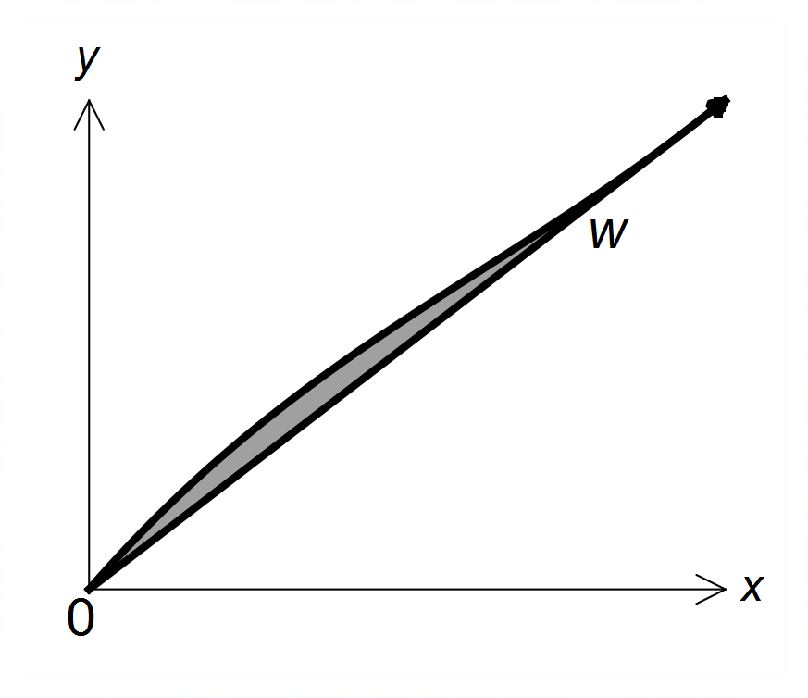

**End of Section One**

**Additional working space**

Question number(s): ……………………

**Additional working space**

Question number(s): ……………………

WATP acknowledges the permission of the School Curriculum and Assessment Authority in providing instructions to students.